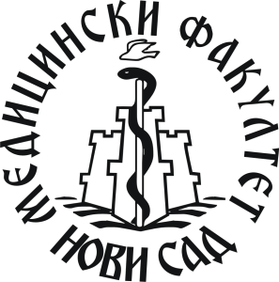
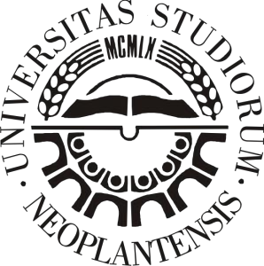

UNIVERSITY OF NOVI SAD

FACULTY OF MEDICINE

TITLE

Novi Sad, February 2022

